From:

“Wipe the Soviet Union Off the Map”, 204 Atomic Bombs against 66 Major Cities, US Nuclear Attack against USSR Planned During World War II

When America and the Soviet Union Were Allies
By Prof Michel Chossudovsky
Global Research, October 27, 2018
Region: Russia and FSU, USA
Theme: History, Militarization and WMD
In-depth Report: Nuclear War

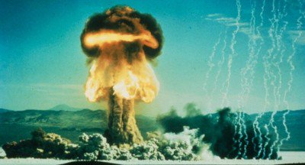
To read this article in other versions, click: French, German, and Russian.
First published November 4, 2017. Revisions to the English Text, December 10, 2017
On March 1st, 2018 president Vladimir Putin unveiled an array of advanced military technologies in response to renewed US threats to wipe the Russian Federation off the Map, as contained in Trump’s 2018 Nuclear Posture Review.
It should be understood that these US nuclear threats directed against Russia predate the Cold War. They were first formulated at the height of World War II under the Manhattan Project when the US and the Soviet Union were allies.
***
According to a secret document dated September 15, 1945, “the Pentagon had envisaged blowing up the Soviet Union with a coordinated nuclear attack directed against major urban areas.
All major cities of the Soviet Union were included in the list of 66 “strategic” targets. The tables below categorize each city in terms of area in square miles and the corresponding number of atomic bombs required to annihilate and kill the inhabitants of selected urban areas.
Six atomic bombs were to be used to destroy each of the larger cities including Moscow, Leningrad, Tashkent, Kiev, Kharkov, Odessa.
The Pentagon estimated that a total of 204 atomic bombs would be required to “Wipe the Soviet Union off the Map”. The targets for a nuclear attack consisted of sixty-six major cities.
To undertake this operation the “optimum” number of bombs required was of the order of 466 (see document below)
One single atomic bomb dropped on Hiroshima resulted in the immediate death of 100,000 people in the first seven seconds. Imagine what would have happened if 204 atomic bombs had been dropped on major cities of the Soviet Union as outlined in a secret U.S. plan formulated during the Second World War.
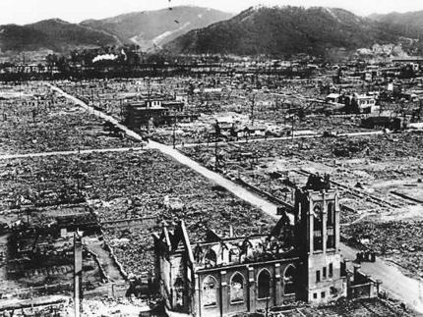
Hiroshima in the wake of the atomic bomb attack, 6 August 1945
The document outlining this diabolical military agenda had been released in September 1945, barely one month after the bombing of Hiroshima and Nagasaki (6 and 9 August, 1945) and two years before the onset of the Cold War (1947).

Video produced by South Front
The secret plan dated September 15, 1945 (two weeks after the surrender of Japan on September 2, 1945 aboard the USS Missouri, see image below) , however, had been formulated at an earlier period, namely at the height of World War II, at a time when America and the Soviet Union were close allies.
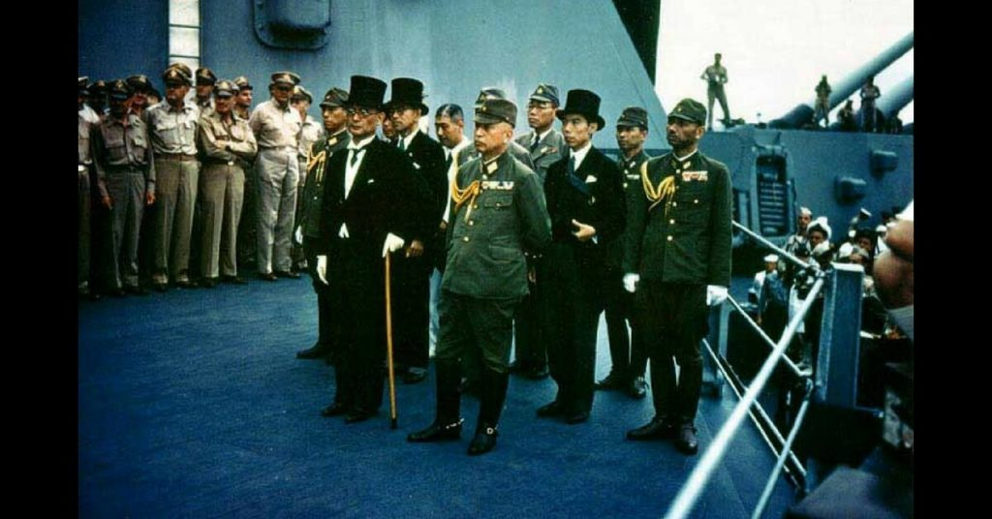
It is worth noting that Stalin was first informed through official channels by Harry Truman of the infamous Manhattan Project at the Potsdam Conference on July 24, 1945, barely two weeks before the attack on Hiroshima.
The Manhattan project was launched in 1939, two years prior to America’s entry into World War II in December 1941. The Kremlin was fully aware of the secret Manhattan project as early as 1942.
Were the August 1945 Hiroshima and Nagasaki attacks used by the Pentagon to evaluate the viability of a much larger attack on the Soviet Union consisting of more than 204 atomic bombs? The key documents to bomb 66 cities of the Soviet Union (15 September 1945) were finalized 5-6 weeks after the Hiroshima and Nagasaki bombings (6, 9 August 1945):
“On September 15, 1945 — just under two weeks after the formal surrender of Japan and the end of World War II — Norstad sent a copy of the estimate to General Leslie Groves, still the head of the Manhattan Project, and the guy who, for the short term anyway, would be in charge of producing whatever bombs the USAAF might want. As you might guess, the classification on this document was high: “TOP SECRET LIMITED,” which was about as high as it went during World War II. (Alex Wellerstein, The First Atomic Stockpile Requirements (September 1945)
The Kremlin was aware of the 1945 plan to bomb sixty-six Soviet cities.
The documents confirm that the US was involved in the “planning of genocide” against the Soviet Union.

Let’s cut to the chase. How many bombs did the USAAF request of the atomic general, when there were maybe one, maybe two bombs worth of fissile material on hand? At a minimum they wanted 123. Ideally, they’d like 466. This is just a little over a month after the bombings of Hiroshima and Nagasaki.
Of course, in true bureaucratic fashion, they provided a handy-dandy chart (Alex Wellerstein, op. cit)
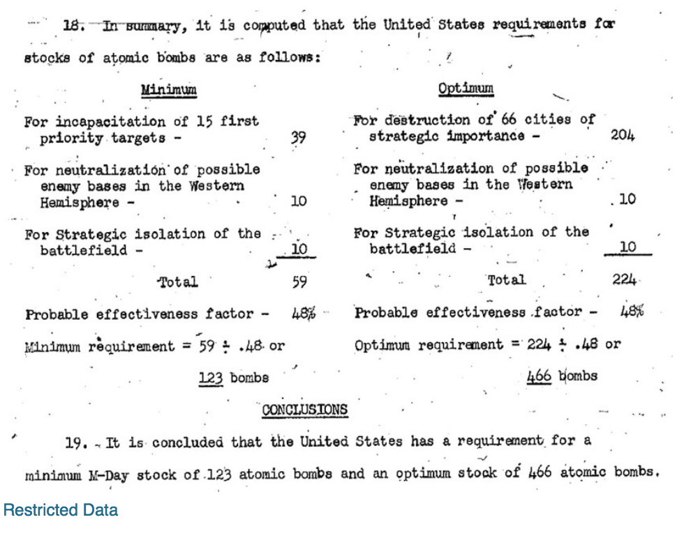
http://blog.nuclearsecrecy.com/wp-content/uploads/2012/05/1945-Atomic-Bomb-Production.pdf
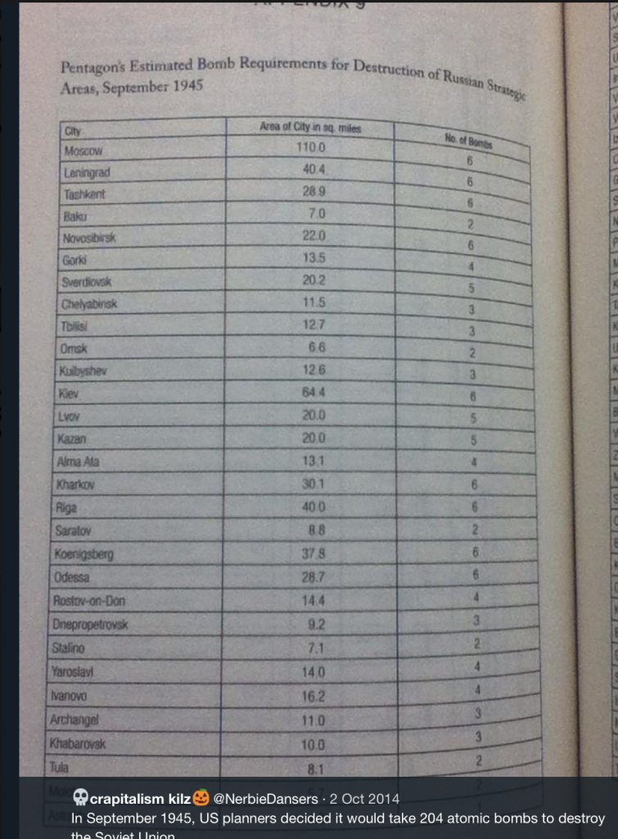
Pentagon Plans to Destroy Dozens of Soviet Cities and the So-called Cold War
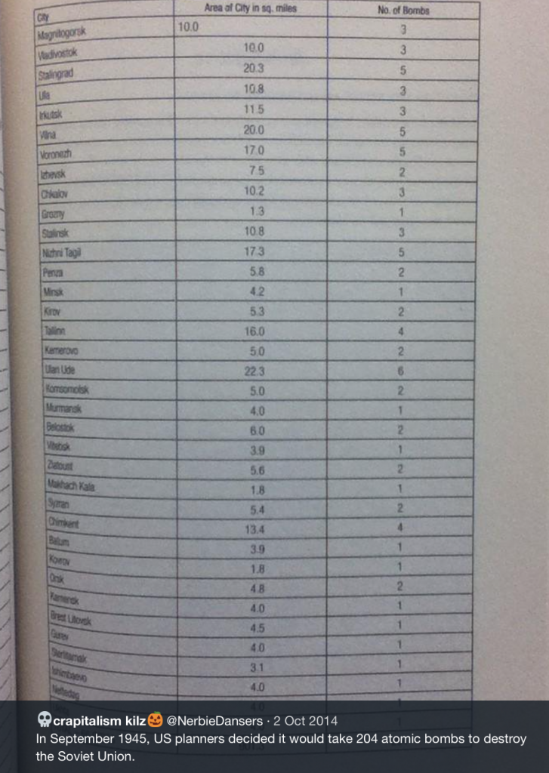
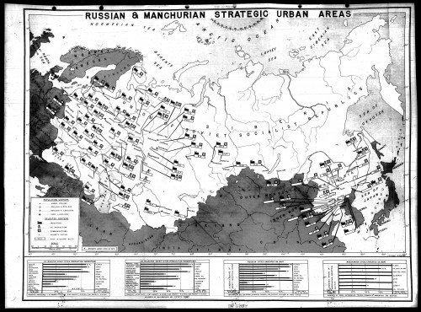
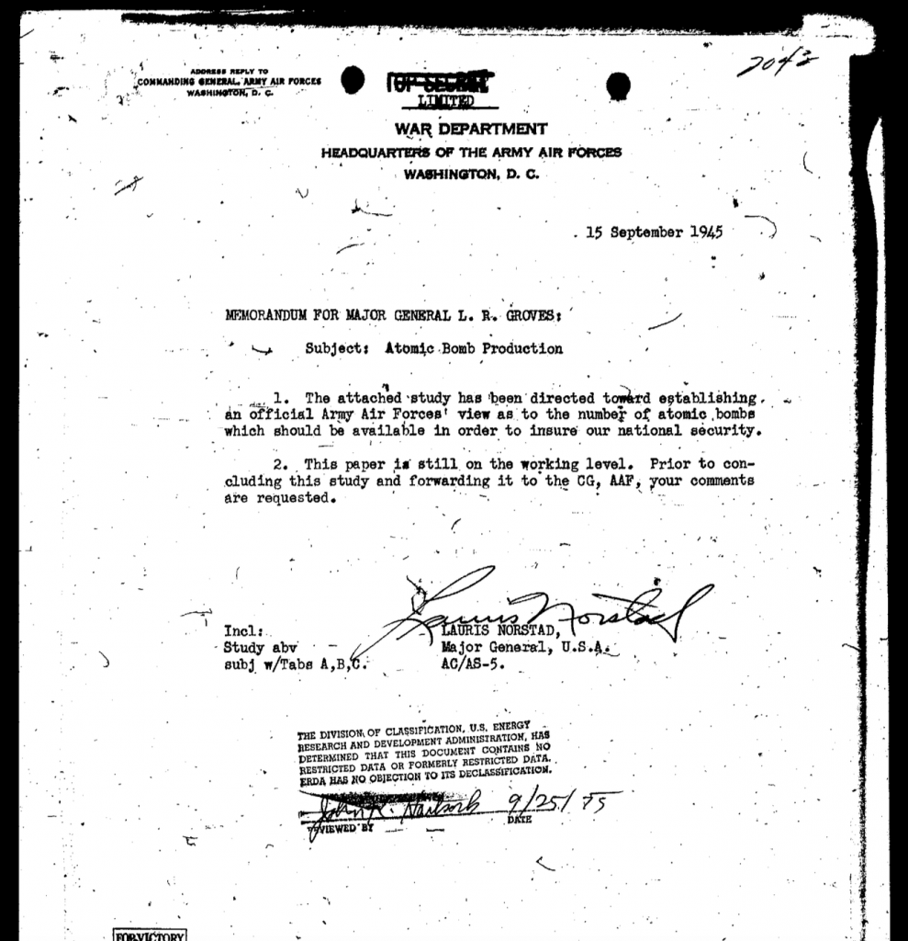
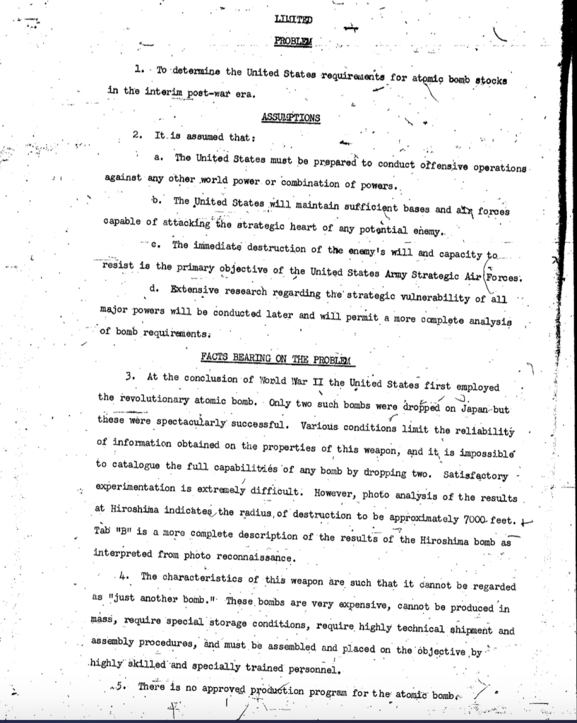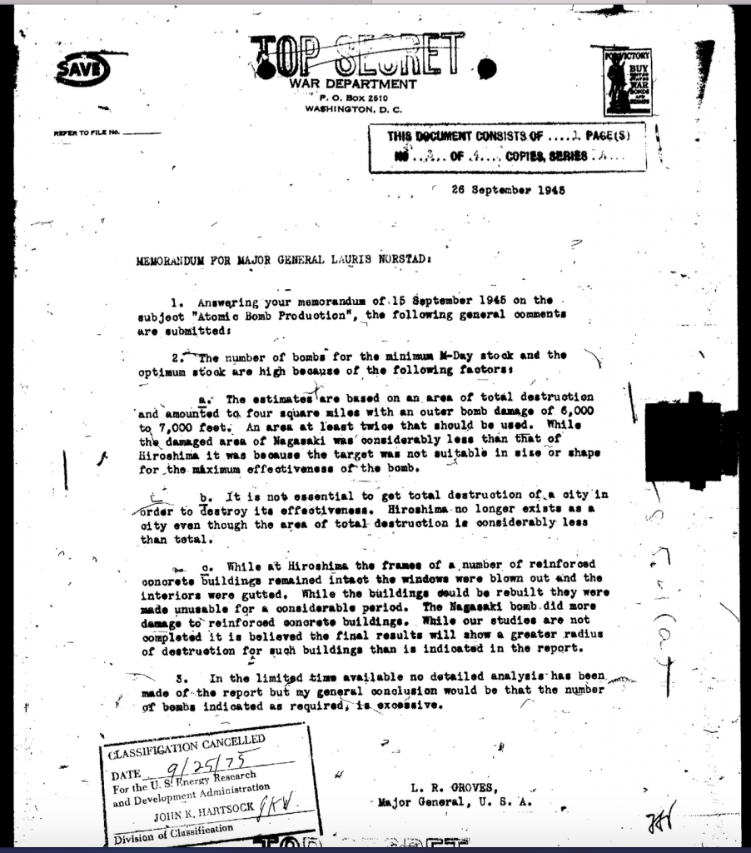
The Nuclear Arms Race
Central to our understanding of the Cold War which started (officially) in 1947, Washington’s September 1945 plan to bomb 66 cities into smithereens played a key role in triggering the nuclear arms race.
The Soviet Union was threatened and developed its own atomic bomb in 1949 in response to 1942 Soviet intelligence reports on the Manhattan Project.
While the Kremlin knew about these plans to “Wipe out” the USSR, the broader public was not informed because the September 1945 documents were of course classified.
Today, neither the September 1945 plan to blow up the Soviet Union nor the underlying cause of the nuclear arms race are acknowledged. The Western media has largely focussed its attention on the Cold War US-USSR confrontation. The plan to annihilate the Soviet Union dating back to World War II and the infamous Manhattan project are not mentioned.
Washington’s Cold War nuclear plans are invariably presented in response to so-called Soviet threats, when in fact it was the U.S. plan released in September 1945 (formulated at an earlier period at the height of World War II) to wipe out the Soviet which motivated Moscow to develop its nuclear weapons capabilities.
The assessment of the Bulletin of the Atomic Scientists mistakenly blamed and continue to blame the Soviet Union for having launched the nuclear arms race in 1949, four years after the release of the September 1945 US Secret Plan to target 66 major Soviet cities with 204 nuclear bombs:
“1949: The Soviet Union denies it, but in the fall, President Harry Truman tells the American public that the Soviets tested their first nuclear device, officially starting the arms race. “We do not advise Americans that doomsday is near and that they can expect atomic bombs to start falling on their heads a month or year from now,” the Bulletin explains. “But we think they have reason to be deeply alarmed and to be prepared for grave decisions.” (Timeline of the Doomsday Clock, Bulletin of Atomic Scientists, 2017)
IMPORTANT: Had the US decided NOT to develop nuclear weapons for use against the Soviet Union, the nuclear arms race would not have taken place.
Neither The Soviet Union nor the People’s Republic of China would have developed nuclear capabilities as a means of “Deterrence” against the US which had already formulated plans to annihilate the Soviet Union.
The Soviet Union lost 26 million people during World War II.
The Cold War List of 1200 Targeted Cities:
This initial 1945 list of sixty-six cities was updated in the course of the Cold War (1956) to include some 1200 cities in the USSR and the Soviet block countries of Eastern Europe (see declassified documents below). The bombs slated for use were more powerful in terms of explosive capacity than those dropped on Hiroshima and Nagasaki.
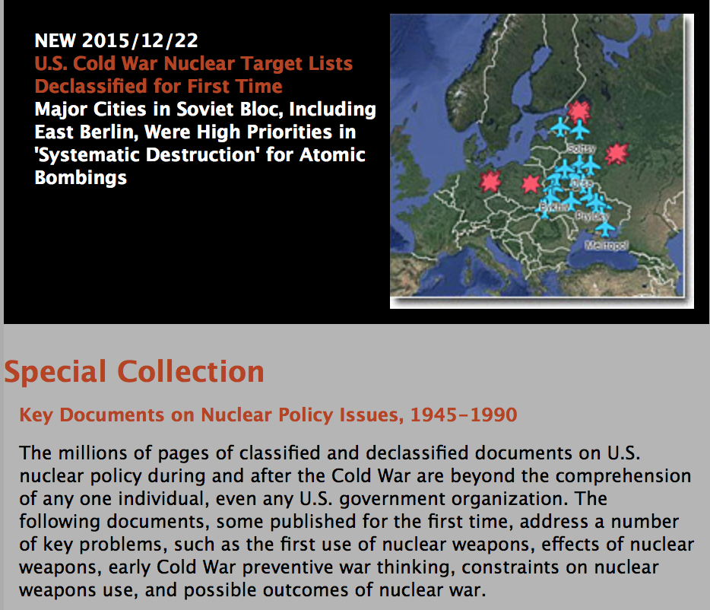
Source: National Security Archive
“According to the 1956 Plan, H-Bombs were to be Used Against Priority “Air Power” Targets in the Soviet Union, China, and Eastern Europe. Major Cities in the Soviet Bloc, Including East Berlin, Were High Priorities in “Systematic Destruction” for Atomic Bombings. (William Burr, U.S. Cold War Nuclear Attack Target List of 1200 Soviet Bloc Cities “From East Germany to China”, National Security Archive Electronic Briefing Book No. 538, December 2015
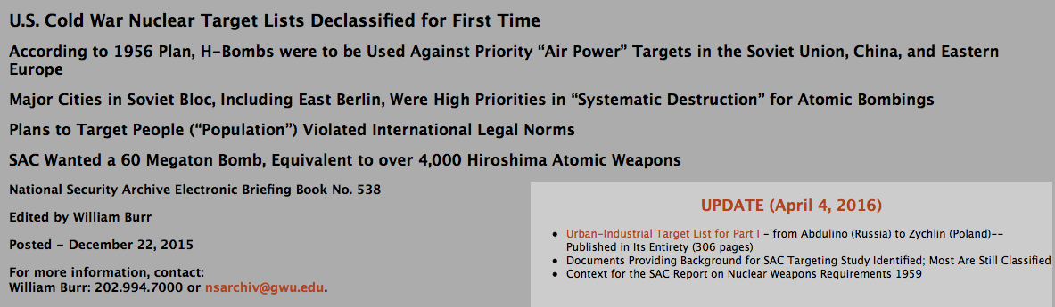
Source: National Security Archive
Washington, D.C., December 22, 2015 – The SAC [Strategic Air Command] Atomic Weapons Requirements Study for 1959, produced in June 1956 and published today for the first time by the National Security Archive www.nsarchive.org, provides the most comprehensive and detailed list of nuclear targets and target systems that has ever been declassified. As far as can be told, no comparable document has ever been declassified for any period of Cold War history.
The SAC study includes chilling details. According to its authors, their target priorities and nuclear bombing tactics would expose nearby civilians and “friendly forces and people” to high levels of deadly radioactive fallout. Moreover, the authors developed a plan for the “systematic destruction” of Soviet bloc urban-industrial targets that specifically and explicitly targeted “population” in all cities, including Beijing, Moscow, Leningrad, East Berlin, and Warsaw. Purposefully targeting civilian populations as such directly conflicted with the international norms of the day, which prohibited attacks on people per se (as opposed to military installations with civilians nearby).National Security Archive Electronic Briefing Book No. 538, December 2015
List of Cities
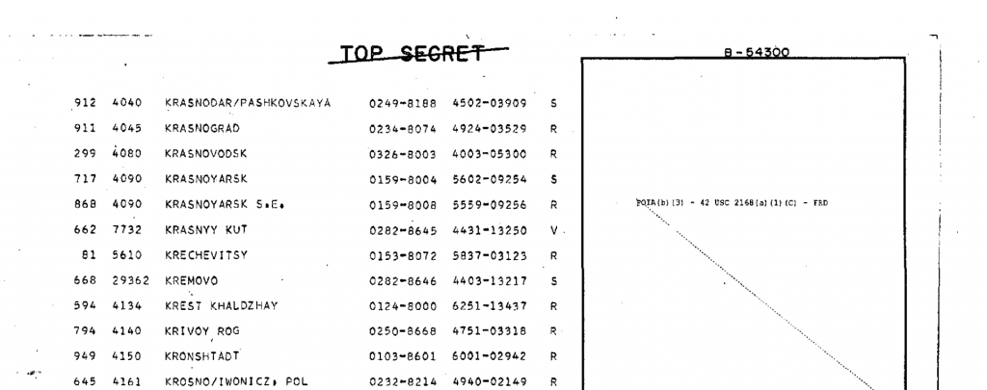
Excerpt of list of 1200 cities targeted for nuclear attack in alphabetical order. National Security Archive, op. cit.
From the Cold War to Donald Trump
In the post Cold War era, under Donald Trump’s “Fire and Fury”, nuclear war directed against Russia, China, North Korea and Iran is “On the Table”.
What distinguishes the October 1962 Missile Crisis to Today’s realities:
1. Today’s president Donald Trump does not have the foggiest idea as to the consequences of nuclear war.
2, Communication today between the White House and the Kremlin is at an all time low. In contrast, in October 1962, the leaders on both sides, namely John F. Kennedy and Nikita S. Khrushchev were accutely aware of the dangers of nuclear annihilation. They collaborated with a view to avoiding the unthinkable.
3. The nuclear doctrine was entirely different during the Cold War. Both Washington and Moscow understood the realities of mutually assured destruction. Today, tactical nuclear weapons with an explosive capacity (yield) of one third to six times a Hiroshima bomb are categorized by the Pentagon as “harmless to civilians because the explosion is underground”.
4. A one trillion ++ nuclear weapons program, first launched under Obama, is ongoing.
5. Today’s thermonuclear bombs are more than 100 times more powerful and destructive than a Hiroshima bomb. Both the US and Russia have several thousand nuclear weapons deployed.
Moreover, an all war against China is currently on the drawing board of the Pentagon as outlined by a RAND Corporation Report commissioned by the US Army
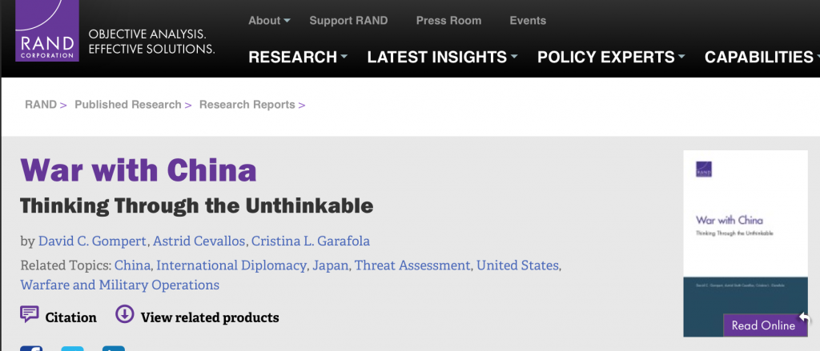
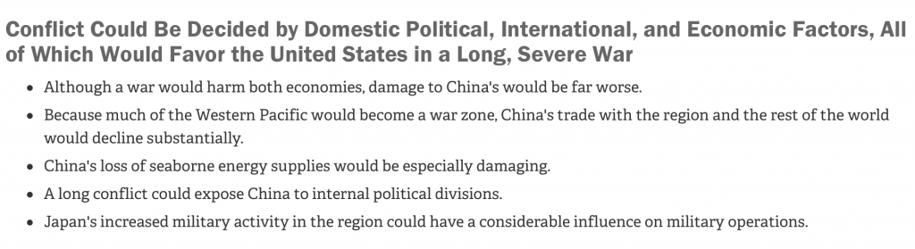
“Fire and Fury”, From Truman to Trump: U.S Foreign Policy Insanity
There is a long history of US political insanity geared towards providing a human face to U.S. crimes against humanity.
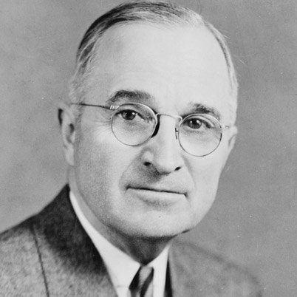
On August 9, 1945, on the day the second atomic bomb was dropped on Nagasaki, president Truman, in a radio address to the American people, concluded that
God is on the side of America with regard to the use of nuclear weapons and that
“He May guide us to use it [atomic bomb] in His ways and His purposes”.
According to Truman: God is with us, he will decide if and when to use the bomb:
[We must] prepare plans for the future control of this bomb.
I shall ask the Congress to cooperate to the end that its production and use be controlled, and that its power be made an overwhelming influence towards world peace.
We must constitute ourselves trustees of this new force–to prevent its misuse, and to turn it into the channels of service to mankind.
It is an awful responsibility which has come to us.
We thank God that it [nuclear weapons] has come to us, instead of to our enemies; and
we pray that He may guide us to use it [nuclear weapons] in His ways and for His purposes” (emphasis added)

The original source of this article is Global Research
Copyright © Prof Michel Chossudovsky, Global Research, 2018

Comment on Global Research Articles on our Facebook page
Become a Member of Global Research
Related Articles

Going Nuclear in the Antipodes: Australia’s Megadeath Complex
Jul 3, 2019

Americans Are Complacent When It Comes to the Dangers of Nuclear War
Jul 2, 2019

Video: US-Russia Relations and the Expiry of Nuclear Treaties. Global Security in Jeopardy
Jun 19, 2019

The Truth-Teller: From the Pentagon Papers to the Doomsday Machine
Jun 13, 2019

Pentagon Nuclear War Plans: Fallout Would Have Wiped Out Many More Countries than Previously Estimated
Jun 5, 2019

Prior to the Cold War: US Nuclear Plans Entailed Blowing Up Hundreds of Chinese, Soviet and Eastern European Cities
May 29, 2019

939
203 162

2228
Articles by:Prof Michel Chossudovsky

About the author:
Michel Chossudovsky is an award-winning author, Professor of Economics (emeritus) at the University of Ottawa, Founder and Director of the Centre for Research on Globalization (CRG), Montreal, Editor of Global Research. He has taught as visiting professor in Western Europe, Southeast Asia, the Pacific and Latin America. He has served as economic adviser to governments of developing countries and has acted as a consultant for several international organizations. He is the author of eleven books including The Globalization of Poverty and The New World Order (2003), America’s “War on Terrorism” (2005), The Global Economic Crisis, The Great Depression of the Twenty-first Century (2009) (Editor), Towards a World War III Scenario: The Dangers of Nuclear War (2011), The Globalization of War, America's Long War against Humanity (2015). He is a contributor to the Encyclopaedia Britannica. His writings have been published in more than twenty languages. In 2014, he was awarded the Gold Medal for Merit of the Republic of Serbia for his writings on NATO's war of aggression against Yugoslavia. He can be reached at crgeditor@yahoo.com
Disclaimer: The contents of this article are of sole responsibility of the author(s). The Centre for Research on Globalization will not be responsible for any inaccurate or incorrect statement in this article. The Centre of Research on Globalization grants permission to cross-post Global Research articles on community internet sites as long the source and copyright are acknowledged together with a hyperlink to the original Global Research article. For publication of Global Research articles in print or other forms including commercial internet sites, contact: publications@globalresearch.ca
www.globalresearch.ca contains copyrighted material the use of which has not always been specifically authorized by the copyright owner. We are making such material available to our readers under the provisions of "fair use" in an effort to advance a better understanding of political, economic and social issues. The material on this site is distributed without profit to those who have expressed a prior interest in receiving it for research and educational purposes. If you wish to use copyrighted material for purposes other than "fair use" you must request permission from the copyright owner.
For media inquiries: publications@globalresearch.ca

